Examples of figures and tables in APA style
Figure 5. Code Occurrences in Student Blogs by Week
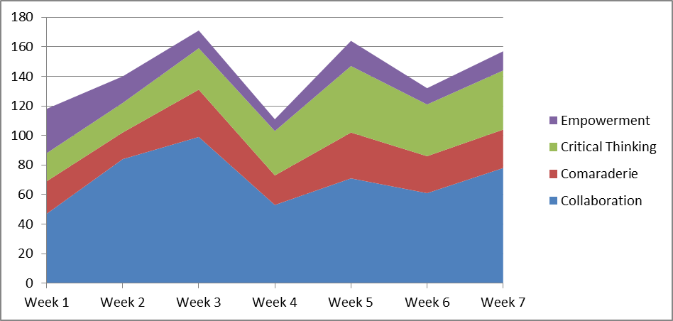

Table 1. Quotes Exemplifying Codes
Code | Exemplar Quotes
Collaboration:
“Thank you for the time to review my paper.  I love the feedback.” | “In the end, when the paper is complete it will represent more than just a completed action research paper it will also represent the importance of collaboration.”
“Within the process, we collect data and think about what patterns emerge. We confer with those in our PLN to see if our thinking makes sense.” | “Most importantly, I gained a partner to help me with this project. She was as excited as I am… and has sights on making this project useful enough to warrant presenting at ASTE this winter!”
Critical Thinking:
“After reading everybody’s comments I realized I had some tweaking to do on my question. (name redacted) pointed out that my verbage of ‘dig deeper’ was too vague and open-ended and that it needed something a little more Bloom’s-esque.” | “What I have begun thinking about is the amount of literacy I am actually using in classroom, and my answer is, “Not enough.” I need to be reading and writing more frequently with my students than I currently am.”

