How to Turn a Classroom Research Project into an Infographic

By Ann Elliott on November 20, 2014 via edudemic.com

Conveying information in a striking, concise way has never been more important, and infographics are the perfect pedagogical tool with which to do so. Below, you’ll find my experience with designing an infographic-friendly classroom research project, explained in a step-by-step process you can implement in your own classroom.

Familiarize Students With the Infographic Concept
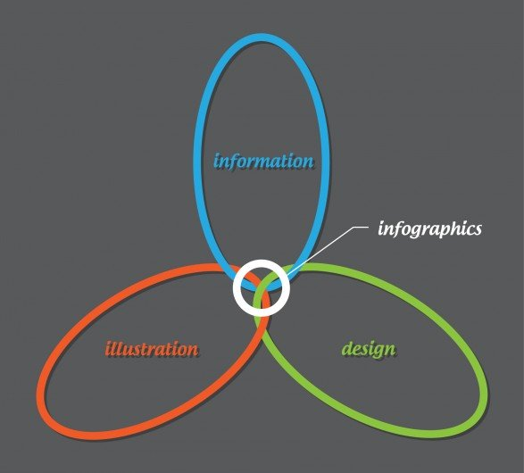
Photo credit: visual.ly
After hearing all the buzz about infographics in education, I thought I’d experiment with the concept in my seventh-grade accelerated English class. I wanted to ease my students into the idea, so we first spent time researching infographics — what they are, how they work, and what kind of information is best conveyed by the medium.
For this process, I recommend NeoMam Studio’s “13 Reasons Why Your Brain Craves Infographics,” which describes their efficacy in a visually compelling way that captivated my students. I then had each of my students pick an infographic on a topic that interests them and share it with the class, explaining why they liked it and how it stood out from the others.

Select an Infographic-Friendly Topic
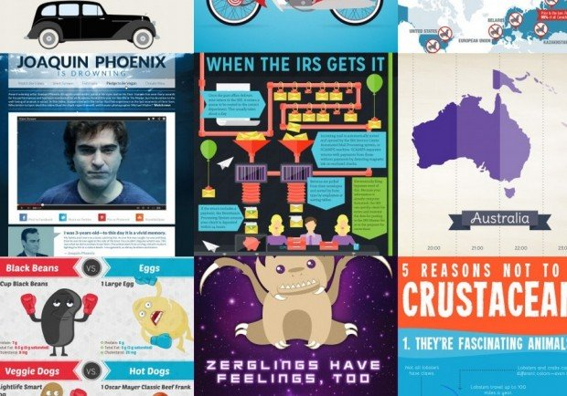
Photo credit: SomethingSoSam
As EdSurge points out, good infographics start with an intriguing but simple “essential question.” Topics that lend themselves well to this medium tend to be easy to understand and readily distilled into a few basic points. Infographics are also ideal for comparison/contrast assignments, as they can juxtapose discrete concepts in a way that underscores similarities or differences.
While I happen to find sentence diagramming and the nuances of punctuation fascinating, I realize most of my students do not share my sentiments, so I had to be judicious about the topic I chose for this assignment. I wanted to select a topic that piqued my students’ interest (read: not grammar), but I also wanted the assignment to have didactic utility. Additionally, I had to choose an assignment that was not overly complex. For example, an assignment to explore the racial dynamics of To Kill a Mockingbird wouldn’t translate well to an infographic.
With these considerations in mind, I decided to have my students create infographics on an approved novel of their choice, detailing the author, plot, setting, characters, etc. In essence, it was a much hipper, more tech-savvy version of a book report, without using those dreaded, groan-inducing words. While this was the assignment I finally chose, infographics would have worked in other curricular areas as well. For instance, if your students give presentations as part of your class, infographics make excellent visual aids. Alternatively, you might require an infographic as an appendix to a research paper.

Begin the Drafting Process by Hand
I explained the assignment to my students, and directed them to a page on educator Kathy Schrock’s website that breaks the infographic creation process down into seven simple steps. I then had them draw a sketch of their infographic by hand as a rough draft, using infographics they found on the Web for inspiration, experimenting with white space, color, font, and the story being told. I gave them feedback on their drafts for revisions before we incorporated any technology.

Choose the Right Templates or Software
Since none of my students had ever done this before, I wanted to start them off with a simple format that provided a basic infographic framework. My colleagues recommended a site where I was able to download five free PowerPoint infographic templates that I then shared with my students. They relied solely on these PowerPoint templates for this assignment, so they could get a feel for the creative process.
For future assignments, I’ll have them use more sophisticated resources that your students might be savvy enough to try immediately. For instance, Piktochart is the leading Web-based infographic software, and special pricing is available for educators. The software has more than 100 categorized themes, 1,000 images to choose from, and user-friendly editing tools. Piktochart also allows users to share their infographics by exporting to Slideshare or Evernote, linking or embedding, or sharing via email or social media.

Refine Content and Design
I encouraged my students to arrange their infographics according to the inverted pyramid method, putting the most important information at the top. I suggested specific elements they might include in their projects, including data (such as number of copies of the book sold to date), flowcharts, profiles of the author, timelines (a sequential layout of the plot’s major events), and word clouds. I heavily emphasized the research aspect of the assignment and required students to include citations in their infographics.
As you look at your students’ infographics, give them feedback on how conducive the layout and color scheme are to the flow of information. Teacher Web points out that the lines of the layout should guide the viewer’s eye from point to point in a logical fashion; arrows are one way to do this. Also help your students choose colors that differentiate ideas and highlight main points. For theme graphics — or graphics that reflect the content — explore the Creative Commons area of Flickr with your students for images that are free of copyright issues.

Infographic Resources and Tools for Educators
- Kathy Schrock’s seven-step guide for creating infographics is a simple, but thorough summary of the process that is ideal as an assignment handout.
- Piktochart is a Web-based infographic software that has a vast selection of themes, graphics, and easy-to-use editing tools. The service is free to get started, then offers special pricing for educators.
- Hubspot offers five free, fully customizable PowerPoint templates with which to create infographics.
Easel.ly is another Web-based infographic tool that gives users 12 complimentary templates to start. The templates are customizable and allow users to add their own graphics with one click.

Share and Critique
Once my students finished their infographics, we displayed them on the projector screen and discussed as a class whether each was readable, interesting, eye-catching, informative, and well-substantiated. Some of my students later chose to share their work via Twitter and Facebook. I keep student portfolios for my classes, so I also arranged to have high-resolution copies of each student’s infographic printed to keep on file.
Infographics integrate research, technology, and creativity in a way that no other pedagogical medium does. They brought a literature-based research assignment to life for my students, transforming what would’ve been a mundane book report into an interactive, tech-savvy endeavor. With the outline I’ve given you of my foray into infographics, you can now build on my experience to develop an infographic assignment tailor-made for your curriculum and students.

